Software Requirements Specification
for
Thoughts Prediction
Prepared by Smit Gandhi
Organization: EduNext Pvt Ltd
Date Created: 02/05/2026

Table of Contents

[Note: The Table of Contents will be automatically generated when you open this document in Microsoft Word. If it doesn't appear, right-click and select 'Update Field']

1. Introduction

1.1 Purpose
The purpose of Thoughts Prediction is to solve What people are thinkin with their thoughts as defined in the user inputs.

1.2 Intended Audience
This document is intended for:
- Admin
- End User
- Development Team
- Project Managers

1.3 Project Scope

Included in scope:
- identify user thoughts

Excluded from scope:
- Hardware manufacturing
- Third-party marketing

1.4 Document Conventions
- Standard IEEE formatting
- Bold text for UI elements

1.5 References
- HIPAA: Health Insurance Portability and Accountability Act

2. Overall Description

2.1 Product Perspective
Thoughts Prediction is a Web Application for the Mental sector.

2.2 Product Features
- identify user thoughts

2.3 User Classes and Characteristics

Admin
- Tech-savvy
- Frequent use

End User
- Basic computer skills
- Occasional use

2.4 Operating Environment
- Web browser on desktop or mobile

2.5 Design and Implementation Constraints
- HIPAA compliance
- Python backend
- SQL database

2.6 User Documentation
- User Manual

2.7 Assumptions and Dependencies

Assumptions:
- Users have stable internet connection

Dependencies:
- Python
- SQL database
- Web browser

3. System Features

3.1 User Thought Identification
Description: The system identifies user thoughts based on their input.

Stimulus/Response Sequences:
Stimulus: User inputs their thoughts or feelings
Response: System processes the input and predicts the user's thoughts.

Functional Requirements:
- The system shall accept user input through a web interface.
- The system shall use a Python-based backend to process user input and predict thoughts.
- The system shall store user input and predicted thoughts in a SQL database.

3.2 User Authentication
Description: The system authenticates users to ensure secure access.

Stimulus/Response Sequences:
Stimulus: User attempts to log in with credentials
Response: System verifies credentials and grants access if valid.

Functional Requirements:
- The system shall require users to authenticate before accessing the application.
- The system shall use secure authentication protocols to protect user credentials.
- The system shall comply with HIPAA regulations for sensitive data handling.

3.3 Dashboard for Admin and End User
Description: The system provides a dashboard for admin and end users to view and interact with predicted thoughts.

Stimulus/Response Sequences:
Stimulus: User logs in and navigates to the dashboard
Response: System displays the user's predicted thoughts and relevant information.

Functional Requirements:
- The system shall display a user-friendly dashboard for admin and end users.
- The system shall provide functionality for users to view and interact with their predicted thoughts.

4. External Interface Requirements

4.1 User Interfaces
The system will have a web-based user interface built with React and TypeScript, supporting user authentication and role-based access control for Admin and End User. The interface will include a dashboard for real-time thought prediction and user management.

User Interface Architecture:
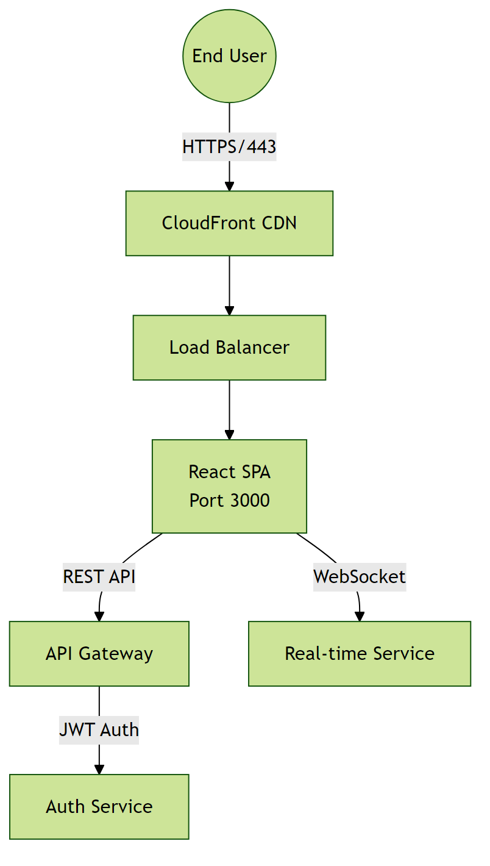

4.2 Hardware Interfaces
The system does not have direct hardware integrations. All infrastructure is virtualized and managed through containerization.

Hardware Interface Architecture:
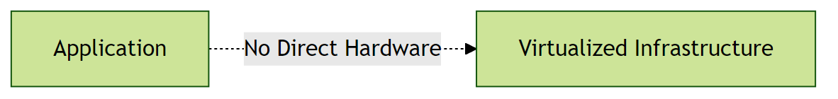

4.3 Software Interfaces
The system will use a PostgreSQL database for storing user data and thought predictions. It will also integrate with external services for user authentication and HIPAA compliance.

Software Interface Architecture:
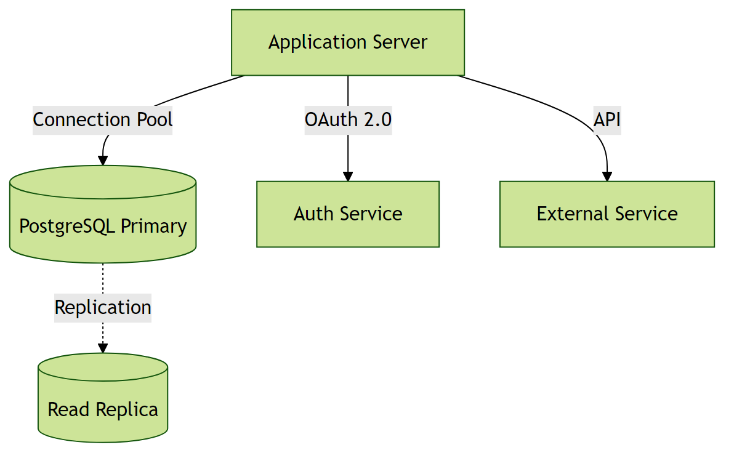

4.4 Communication Interfaces
The system will use HTTPS for secure communication between the client and server. It will also use WebSockets for real-time updates.

Communication Interface Architecture:
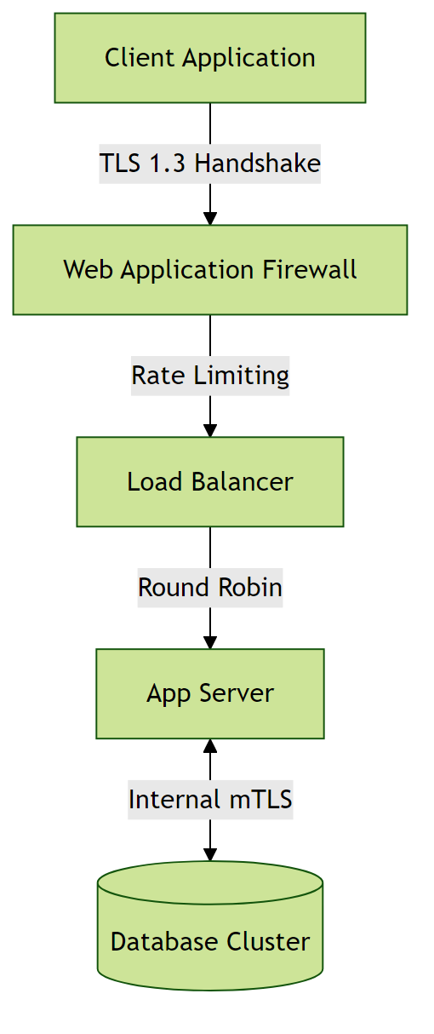

5. Non-Functional Requirements

5.1 Performance Requirements
- The system shall support less than 100 concurrent users without performance degradation.
Rationale: To accommodate expected user scale.
- The system shall respond to user requests within a normal response time.
Rationale: To ensure a responsive user experience.

5.2 Safety Requirements

5.3 Security Requirements
- The system shall implement authentication for all users.
Rationale: To ensure only authorized access to the system.
- The system shall comply with HIPAA regulations.
Rationale: To protect sensitive health information.

5.4 Quality Attributes
- The application must achieve high availability.
Rationale: To ensure reliability for users.
- The system shall be maintainable with modular architecture.
Rationale: To enable efficient updates and reduce long-term maintenance costs.

6. Glossary

6.1 Technical Terms
API: Application Programming Interface - a set of protocols and tools for building software applications.
HIPAA: Health Insurance Portability and Accountability Act - a regulation in US law on data protection and privacy.
Python: A high-level, interpreted programming language used for developing the backend of the system.
SQL: Structured Query Language - a language for managing and manipulating data in relational database management systems.

6.2 Acronyms and Abbreviations
NFR: Non-Functional Requirements - operational constraints defining system performance, security, and quality.

6.3 System Components
Authentication Service: Component responsible for verifying user credentials and managing access tokens.
Database Layer: Persistent storage layer managing data operations and ensuring data integrity.

6.4 Technologies
Web Application: A software application that runs on a web server and is accessed through a web browser.
Cloud Service Providers: Third-party services that provide cloud-based infrastructure for deployment and scaling.

6.5 Performance Metrics
Concurrent Users: Number of users actively using the system simultaneously without performance degradation.
Response Time: Time elapsed between a user request and the system's response.

6.6 Security Terms
Authentication: Process of verifying the identity of a user or system.
Authorization: Process of determining whether a user has access to a particular resource or functionality.
Encryption: Process of converting plaintext data into unreadable ciphertext to protect it from unauthorized access.

6.7 Quality Attributes
Reliability: Ability of the system to perform its required functions under normal operating conditions.
Scalability: Ability of the system to handle increased load or demand without decreasing performance.
Maintainability: Ease with which the system can be maintained, updated, or modified.

7. Assumptions

Assumption 1:
Users have stable internet connections with a minimum bandwidth of 5 Mbps.
Impact: If users have unstable or low-bandwidth internet connections, the system's performance may degrade, leading to a poor user experience and potential errors.

Assumption 2:
The Python backend and SQL database will be properly configured and maintained.
Impact: If the backend or database is not properly configured or maintained, the system may experience performance issues, errors, or security vulnerabilities.

Assumption 3:
Users will access the system primarily through modern web browsers (Chrome 90+, Firefox 88+, Safari 14+, Edge 90+).
Impact: If users attempt to access via older browsers, critical features may not function properly, requiring additional development effort for backwards compatibility or limiting the user base.

Assumption 4:
The system will be deployed on infrastructure that can handle less than 100 concurrent users.
Impact: If the system experiences more than 100 concurrent users, performance may degrade, requiring emergency infrastructure scaling and potential architecture modifications.

Assumption 5:
Business stakeholders will be available for weekly requirement reviews and timely decision-making.
Impact: Lack of stakeholder availability could lead to requirement ambiguities, implementation delays, and potential rework due to misaligned expectations.

Assumption 6:
The database server will have at least 500GB of available storage with capacity to expand.
Impact: Insufficient storage capacity would limit data retention capabilities and could cause system failures if storage limits are reached unexpectedly.

Assumption 7:
Users possess basic computer literacy and familiarity with web-based applications.
Impact: If users lack basic digital skills, additional training programs and simplified UI/UX would be required, increasing project costs and extending the rollout timeline.

Assumption 8:
Regulatory requirements for data privacy (HIPAA) will remain stable during development.
Impact: Changes in data privacy regulations could necessitate significant architectural changes, additional compliance features, and potential project delays.

